KID Firmware Upgrade

In an effort to make the Firmware updates easier we have designed a package that will help you update your KID on any Windows operating system.

http://midniteftp.com/forum/index.php?action=dlattach;topic=4013.0;attach=6486
Firmware Update.
To do a firmware update on The KID you will need the following:
A laptop or PC with Windows XP/7/8/8.1 /1 0 or Linux. Mac is not supported
A USB Mini-B cable (not included).

Procedure:
Go to http://www.midnitesolar.com/firmwareIndex.php and download the latest firmware file. Save the file to a known location on your PC. Your Desktop or My Documents will work.

Double click on the .zip file

This will be a .zip file you will need to unzip the 2 files inside and put them in a folder
together. Note they both need to be in the same folder or the update will not work.

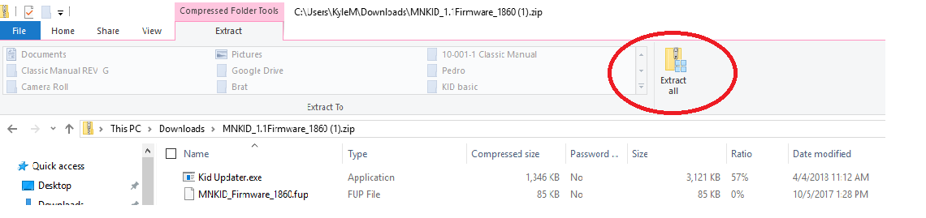

Choose a location and press Extract

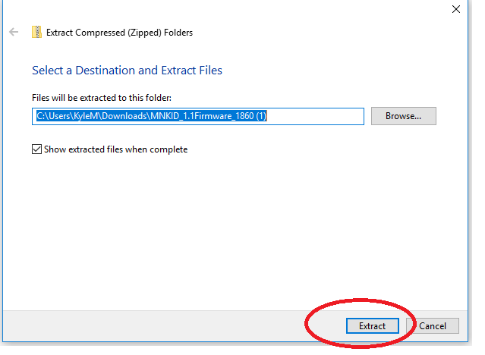

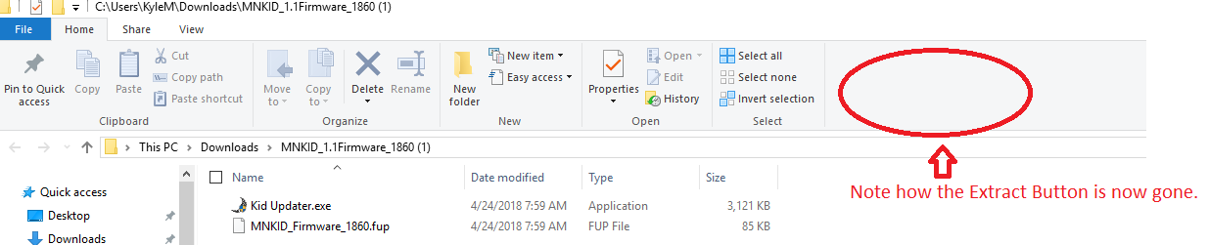

Once the files are unzipped you will have an icon that looks like this:
Double click on this icon.

You might see this error:
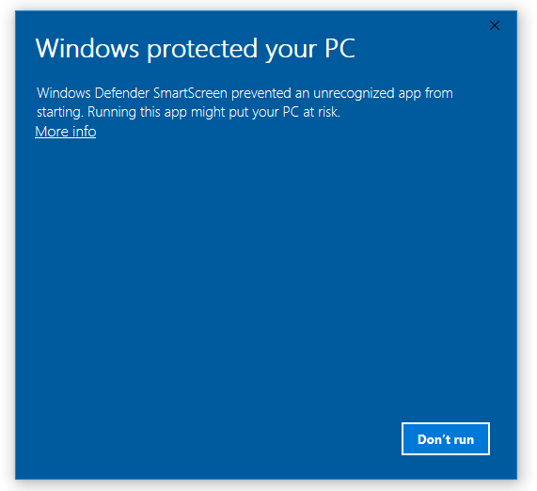

This happens on mostly Windows 8 and Windows 10. If you see this click on the More info.

Then Click on Run anyway.

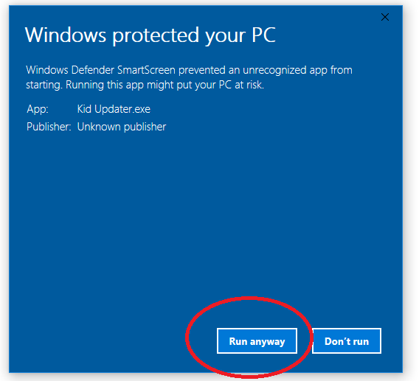

You might get another message asking if you are sure you want to run the Firmware say Yes.

The Application will run and it will look like this:
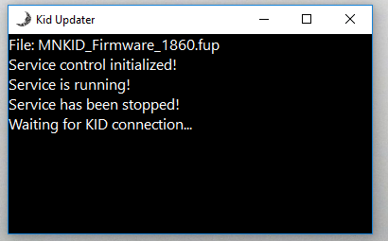

Go to MAIN Menu on The KID And scroll to the right to the TECH menu and press Enter.

Press the down arrow key until Firmware Update is selected and press Enter.

You should see BOOTLOADER 2.5
FIRMWARE UPDATE

Plug in both ends of the USB Mini Cable.

NOTE: Make sure before you hook up the USB cords, that you have launched the Application, and The KID is in either:
BOOTLOADER 2.5
FIRMWARE UPDATE
Or
BOOTLOADER 2.5
FORCED UPDATE

The Application will start to run and look like this:

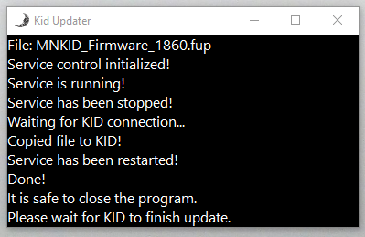

The first green light should start blinking on The KID and "UPDATING...”

It will take up to 2 minutes to update The KID.

The unit will reboot with new updated firmware.

Unplug the USB cables and close the Application your KID is now updated.

If the update process does not complete you might see this error:

BOOTLOADER 2.5
BAD FIRMWARE

You might also see this error on Windows 10 if you tried to update the Firmware without using the Application above.

If you see this error, power down The KID and wait 60 seconds. Then hold the SETUP button while powering up The KID. This will put The KID into update mode. The screen should read:

BOOTLOADER 2.5
FORCED UPDATE

The KID is now ready to retry the firmware update.

